**HCI Project Deliverable 01**

**Presented by:**

Badar Ud Din (16L-4304)

Hammad Ikhlaq (16L-4281)

Safi Ur Rahman (16L-4365)

**Instructor :** Mr. Bismillah Jan

**Project:** Showbiz Information System (All Television Database)

**Date :** 15th April, 2019

**Purpose**

All Television Database is an software for keeping and showing information related to films, television programs and internet streams, including cast, production crew and personnel biographies, plot summaries, trivia, and fan reviews and ratings. It is similar to IMDb which is online database of showbiz information.

**Detailed Working**

**Functionalities:**

* Login
* Sign Up
* Session Expired
* Rating
* Poll
* Ask Question
* Search
* Get favourite
* Watchlist
* NewsLetter
* Coming Soon
* Opening this week

**Prototype:**

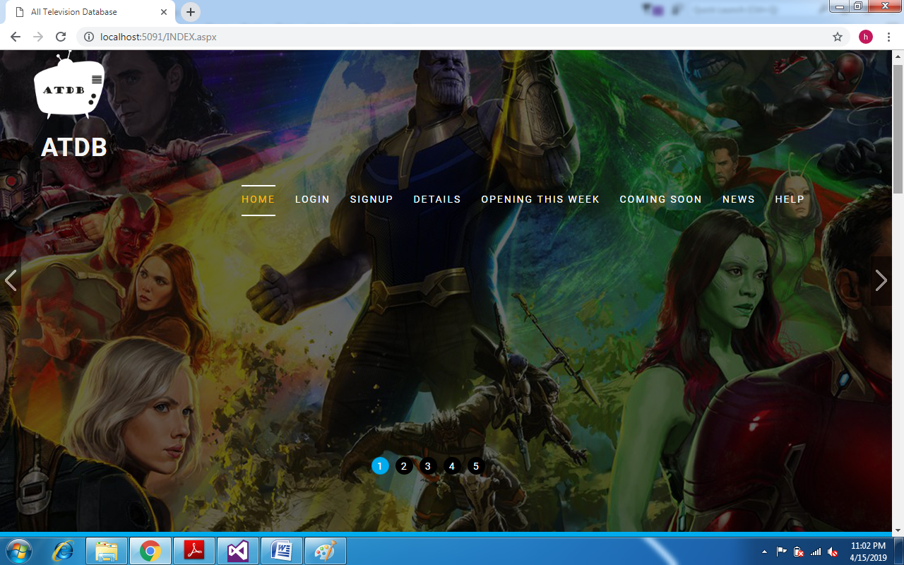

The above picture shows the **Homepage** of our website, the first step is to signup if the user does not have an account otherwise login.

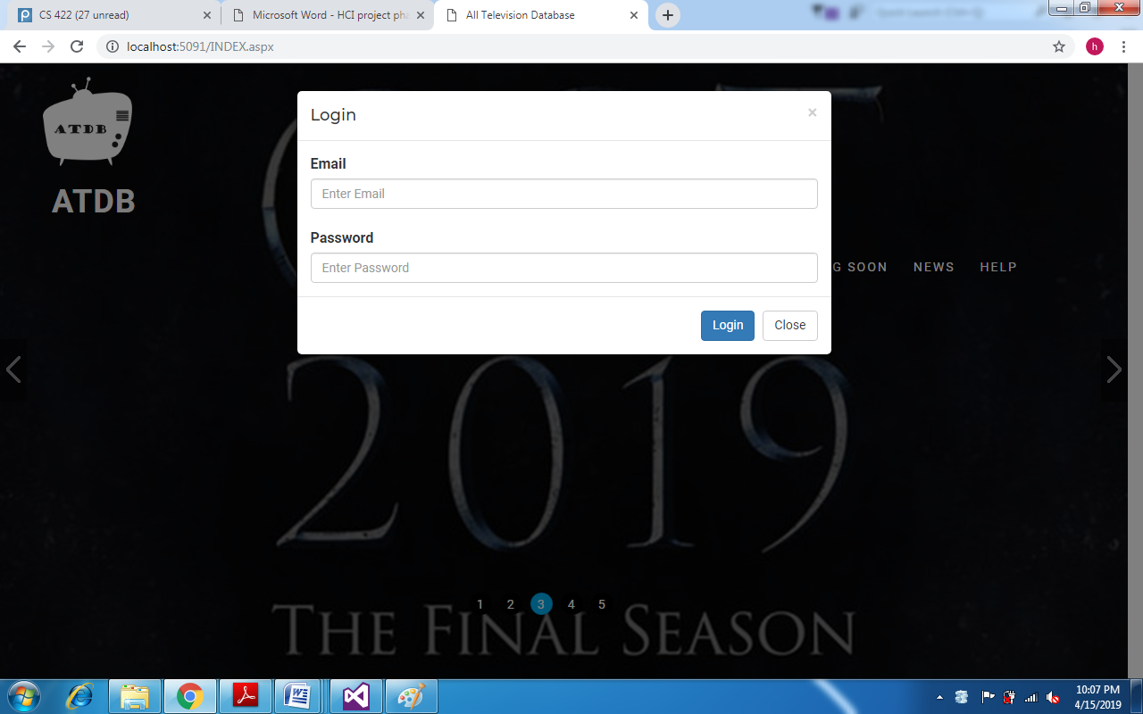

The above picture shows **Login Page**. Error is minimized by providing hints in the text field.

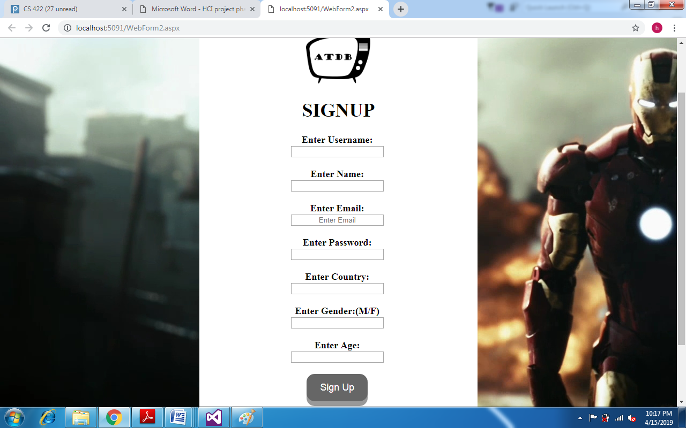

The above picture shows **Sign up Page**.

**Overall Flow:**

